Laboratory 6
Title of the Laboratory Exercise: Transactions
- Introduction and Purpose of Experiment
Aim and Objectives
Aim
- To develop a program to perform concurrent transactions

- Experimental Procedure
    - Analyse the problem statement
    - Design an algorithm for the given problem statement and develop a flowchart/pseudo-code
    - Implement the algorithm in Java language
    - Compile the Java program
    - Test the implemented program
    - Document the Results
    - Analyse and discuss the outcomes of your experiment

- Question
Create a Multithreaded Java program with two threads handling Transactions, U and T. Transactions T and U have at-least one common object and at-least two operations. The program should ensure that the execution of the transactions is serializable (free from conflicts). Proper Concurrency control mechanism needs to be used wherever necessary.
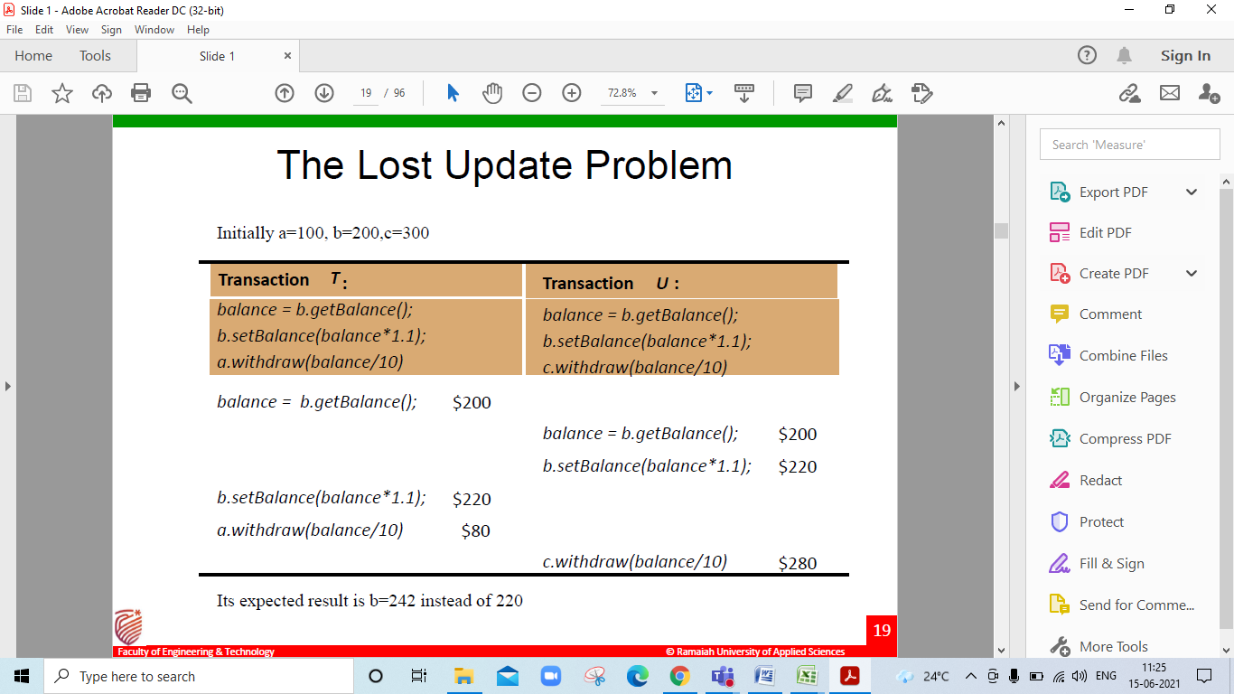
- Computations/Algorithms
Step 1: Start
Step 2: Create a main class to declare thread objects and invoke each thread where, each thread denotes a Transaction
Step 3: Create a generic class Account that wraps an Integer as the underlying data type
Step 4: Create an object of Integer type and a Lock object of ReentrantReadWriteLock in the generic class
Step 5: Declare the following methods in class Account: -
getBalance() – Read operation to return current balance before or after another operation
setBalance() – Write operation to update balance after another operation
deposit() – Write operation to deposit amount
withdraw() – Write operation to check balance and withdraw amount
Step 6: Use the read lock function of the ReentrantReadWriteLock object Lock to safeguard concurrent access to all the read operations in a given transaction i.e. getBalance()
Step 7: Use the exclusive write lock function of the ReentrantReadWriteLock object Lock to safeguard concurrent access to all the write operations in a given transaction i.e. setBalance(), deposit() and withdraw()
Step 8: Create a class Transaction_T that extends thread class
Step 9: Class Transaction_T takes three objects of class Account named a, b and c and the transaction ID as input parameters from the newly created thread object (of class Transaction_T) invoked in main class i.e., any thread invocation of class Transaction_T is a transaction to perform any of the four operations defined in Step 5
Step 10: Using the class Account objects passed during thread invocation, read or write operations are performed inside class Transaction_T in any order
Step 11: Create a class Transaction_U that extends thread class
Step 12: Class Transaction_U takes three objects of class Account named a, b and c and the transaction ID as input parameters from the newly created thread object (of class Transaction_U) invoked in main class i.e., any thread invocation of class Transaction_U is a transaction to perform any of the four operations defined in Step 5
Step 13: Using the class Account objects passed during thread invocation, read or write operations are performed inside class Transaction_U in any order
Step 14: Declare and initialize three objects a, b and c of class Account and pass the objects as parameters of the threads created for classes Transaction_T and Transaction_U

- Presentation of Results
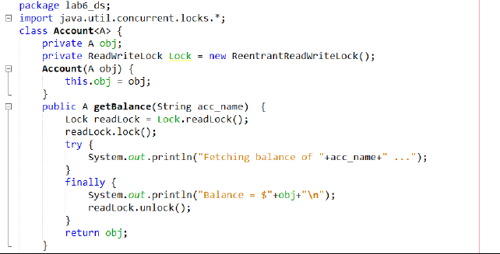
Fig 1 Account class with getBalance() - read operation
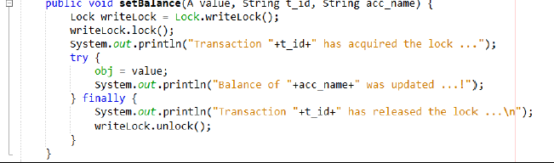
Fig 2 Account class with setBalance() - write operation
Fig 3 Account class with deposit() - write operation
Fig 4 Account class with withdraw() - write operation
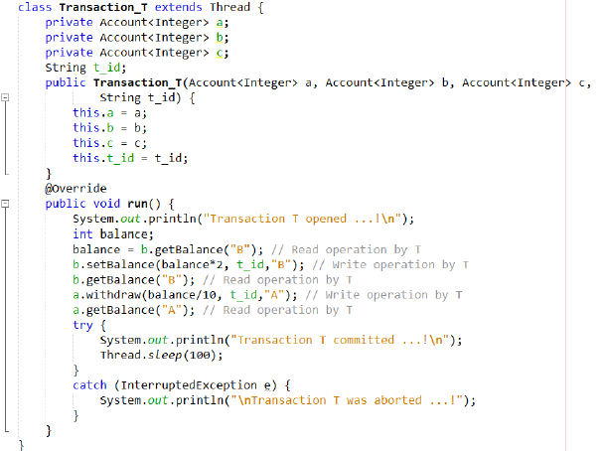
Fig 5 Class Transaction_T showing all read-write operations
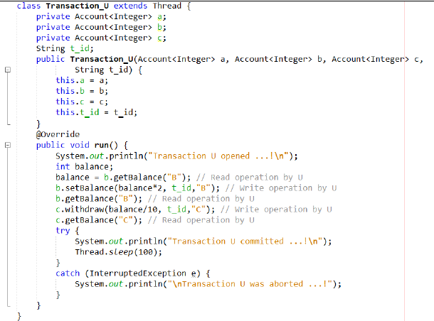
Fig 6 Class Transaction_U showing all read-write operations
Output
For a = $100, b = $200, and c = $300 Initially
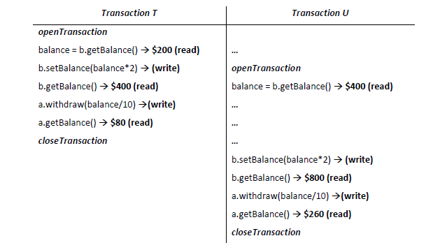
Fig 7 Output showing flow of operations in transaction T
Figure 8 Output showing flow of operations in transaction U

- Analysis and Discussions

• A server can achieve serial equivalence of transactions by serializing access to objects
• A simple example of serializing mechanism is the use of exclusive locks.
• In this locking scheme the server attempts to lock any object that is about to be used by any operation of a client’s transaction.
• If a client requests access to an object that is already locked due to another client’s transaction, the request is suspended and the client must wait until the object is unblocked.
• If a transaction T has already performed a read operation on a particular object, then a concurrent transaction U must not write that object until T commits or aborts.
• To enforce this, a request for a write lock on an object is delayed by the presence of a read lock belonging to another transaction.
• If a transaction T has already performed a write operation on a particular object, then a concurrent transaction U must not read or write that object until T commits or aborts.
• To enforce this, a request for either a read lock or a write lock on an object is delayed by the presence of a write lock belonging to another transaction.

      - Limitations of Experiments
None
      - Limitations of Results
Checked only for Small Data Result May Vary if Checked for large data.
      - Learning happened
To develop a program to perform concurrent transactions
      - Recommendations
None

